Responsive Testing Report

1. Introduction
The objective was to evaluate the application's responsive layout and mobile usability across the following mobile viewport configurations:
- iPhone SE
- iPhone 12
- Pixel 5
The testing focused on identifying responsive design issues and verifying mobile touch interactions.This report documents the responsive testing performed on the SauceDemo application using Chrome DevTools Device Mode.

2. Testing Environment
Item | Details
Application | SauceDemo
Testing Tool | Google Chrome DevTools – Device Mode
Testing Type | Responsive / Mobile Testing
Viewports Tested | iPhone SE, iPhone 12, Pixel 5
Browser | Google Chrome
Environment | Chrome DevTools Device Emulation

3. Responsive Testing Results
During testing, the following issues were identified. The same issues were observed across the iPhone SE, iPhone 12, and Pixel 5 viewports.

RI-001 — Validation Error Message Overlap
Area: Form Validation
Observation: The validation error message overlaps with other UI elements when displayed on the mobile viewport. This affects the readability and presentation of the error message.
Affected Viewports: iPhone SE, iPhone 12, Pixel 5
Result: Issue Found
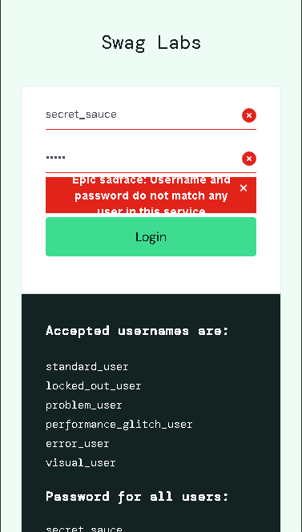

RI-002 — Clear Icon Does Not Clear Input Field
Area: Form Interaction
Observation: The X/clear icon displayed in the input field does not clear the entered data when clicked.
Affected Viewports: iPhone SE, iPhone 12, Pixel 5
Result: Issue Found

RI-003 — Improper Image Resolution
Area: Product Image
Observation: Product images are not rendered or resized appropriately for the mobile viewport, resulting in improper image resolution or display.
Affected Viewports: iPhone SE, iPhone 12, Pixel 5
Result: Issue Found

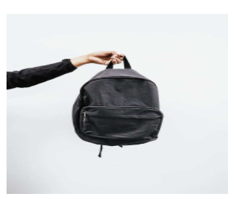

RI-004 — Excessive Gap Between Description and Button
Area: Product Card Layout
Observation: There is an excessive amount of empty space between the product description and the corresponding action button.
Affected Viewports: iPhone SE, iPhone 12, Pixel 5
Result: Issue Found

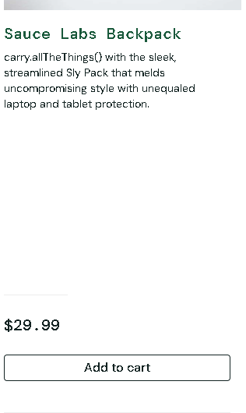

RI-005 — Navigation Bar Is Not Fixed
Area: Navigation
Observation: The navigation bar is not fixed while scrolling. As a result, the navigation bar moves out of the visible viewport when the user scrolls down.
Affected Viewports: iPhone SE, iPhone 12, Pixel 5
Result: Issue Found

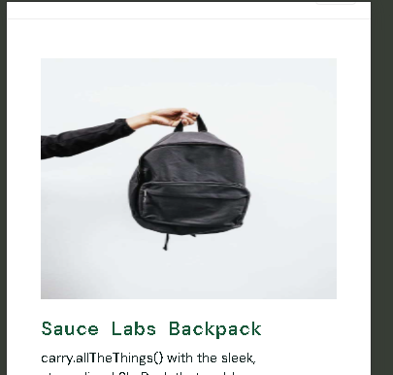

RI-006 — Inconsistent Product Card Size
Area: Dynamic Catalog Slider
Observation: The product cards displayed in the dynamic catalog slider do not maintain consistent dimensions. Different product cards appear with different sizes, resulting in an inconsistent layout.
Affected Viewports: iPhone SE, iPhone 12, Pixel 5
Result: Issue Found
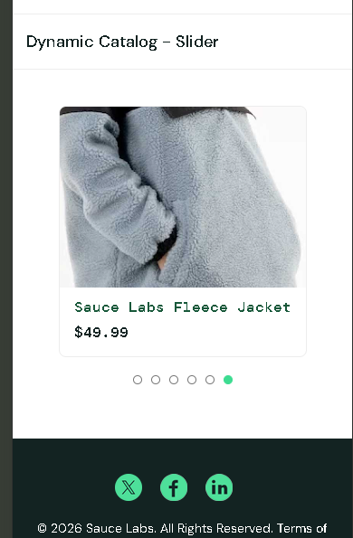

RI-007 — Filter Extends Outside Layout
Area: Product Filter
Observation: The filter control extends outside its expected layout boundary on the mobile viewport, affecting the overall alignment of the page.
Affected Viewports: iPhone SE, iPhone 12, Pixel 5
Result: Issue Found

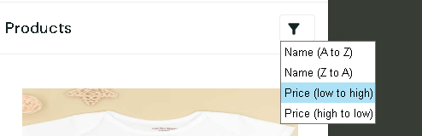

4. Conclusion
Responsive testing of SauceDemo was performed using Chrome DevTools Device Mode on iPhone SE, iPhone 12, and Pixel 5 configurations. Several responsive and mobile UI issues were identified, including validation message overlap, improper image rendering, inconsistent product card dimensions, excessive spacing, non-fixed navigation, and filter positioning issues. The identified issues were observed consistently across the tested mobile viewports.

